17. Restrict template use in AEM using allowedPaths and allowedTemplates

There are 2 ways of restricting use of template in AEM6.2 or CQ5.

1. Using allowedPath property

2. Using allowedTemplates property

allowedPaths property defines the path where the template can be used to create pages. allowedTemplates specify which templates may be used within a specified path.

**allowedPaths:**

When we are creating a template, we will provide allowedpaths String[](ex: /content(/.*)?) value so that this template will be available only under that path to create any pages.

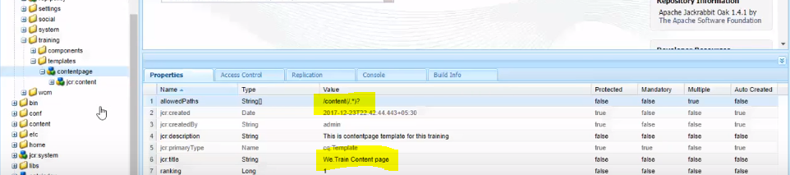

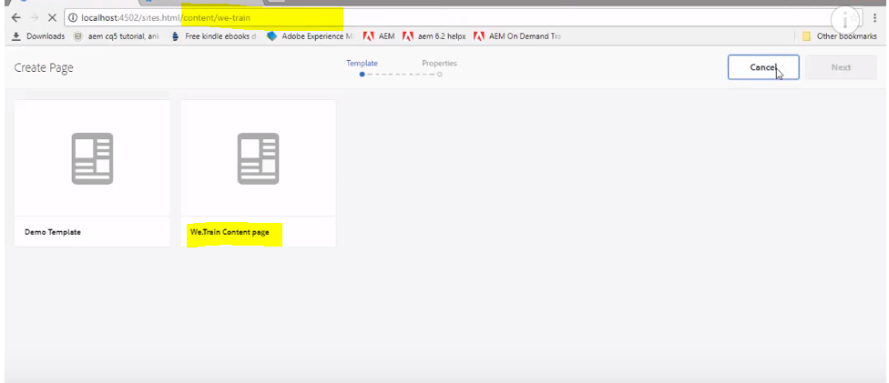

Ex: If we are providing allowed paths value as /content/we-trail(/.*)?, then the template will be available only under /content/we-trail page but not under /content.

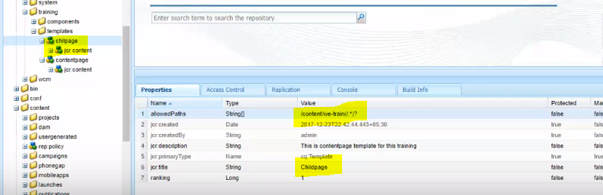

Child page template is not available under /content folder.

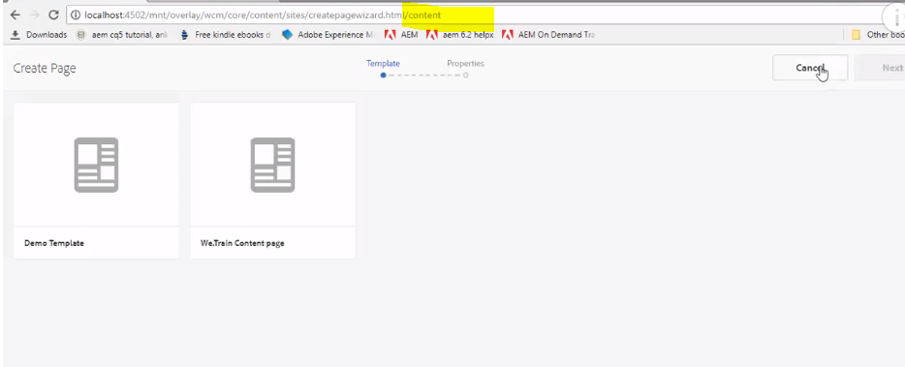

But this same template is available under /content/we-train page.

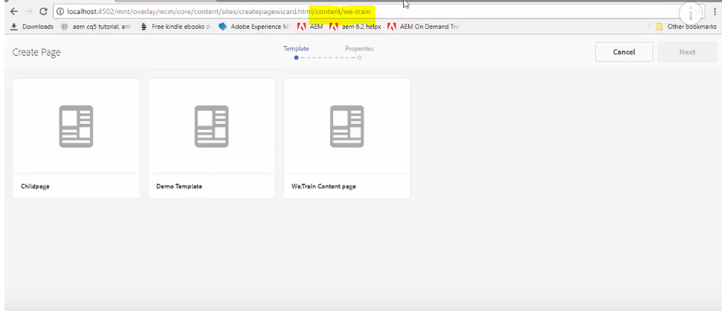

**allowedTemplates:**

There will be default templates available under /content, so that they will be available under our custom projects also.

If we don’t want them to be available in our projects, we can provide a list of templates which you want to see under our project.

Ex:

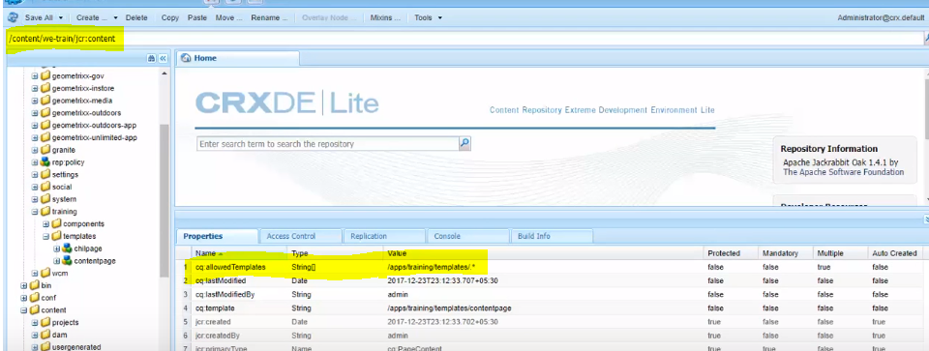

We have provided allowedTemplates value as “/apps/training/templates/.*”, so only these templates will be available under /content/we-retail path.



